Module 01: Project 01

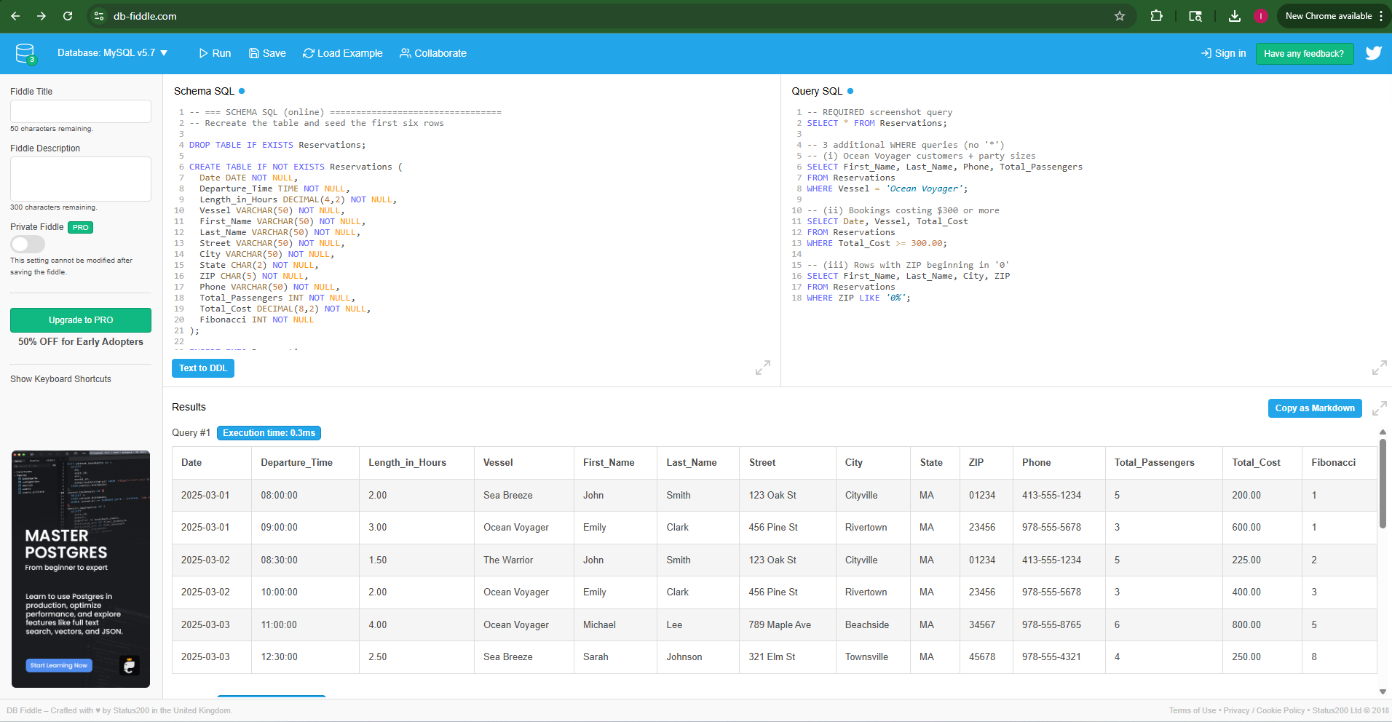

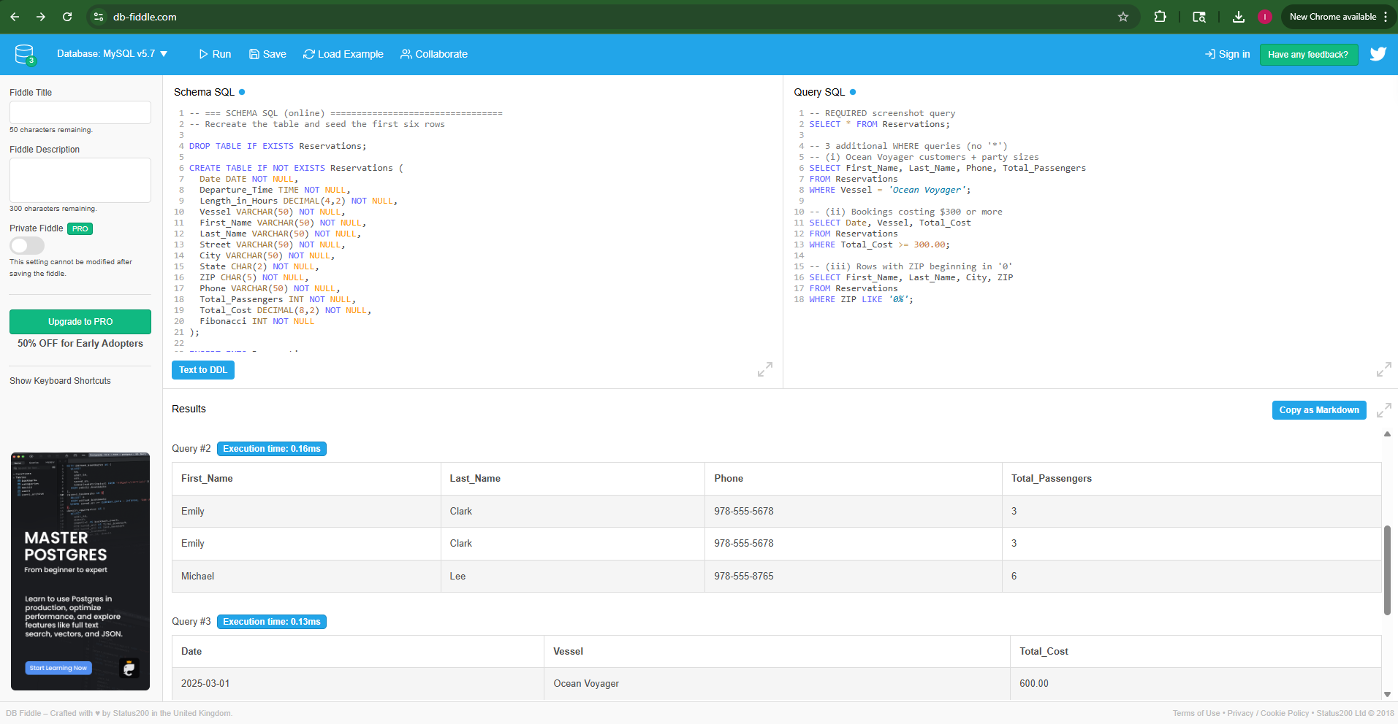

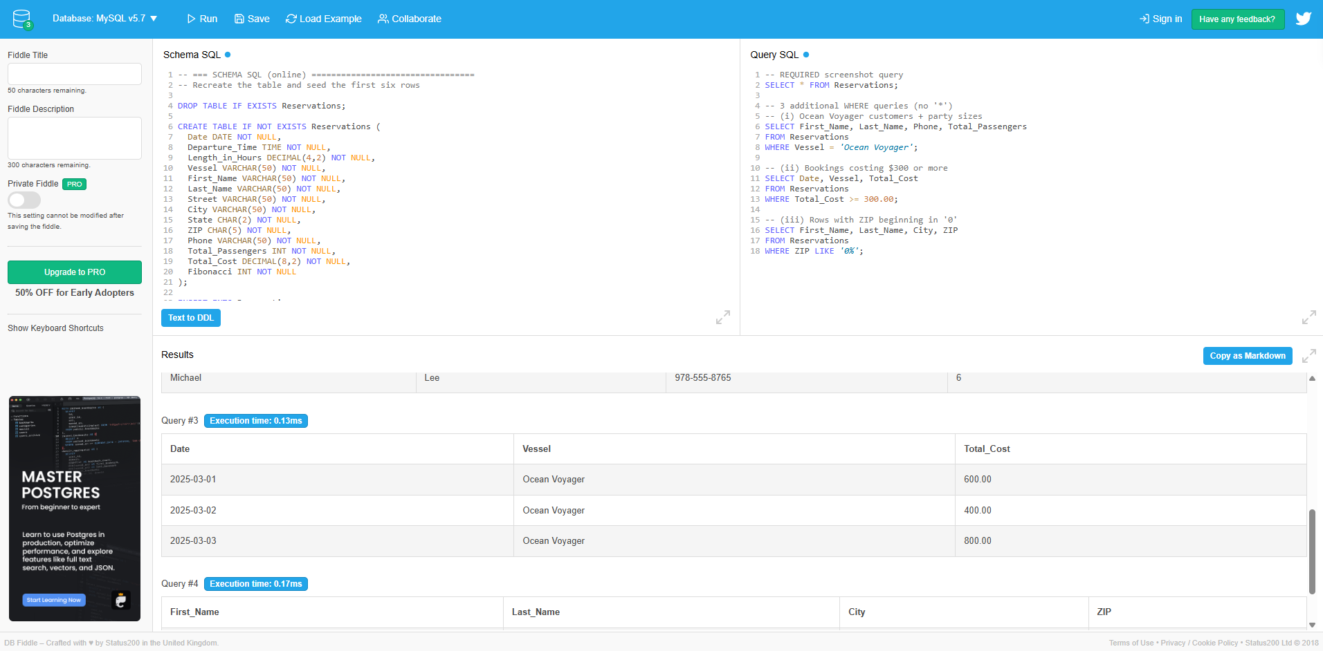

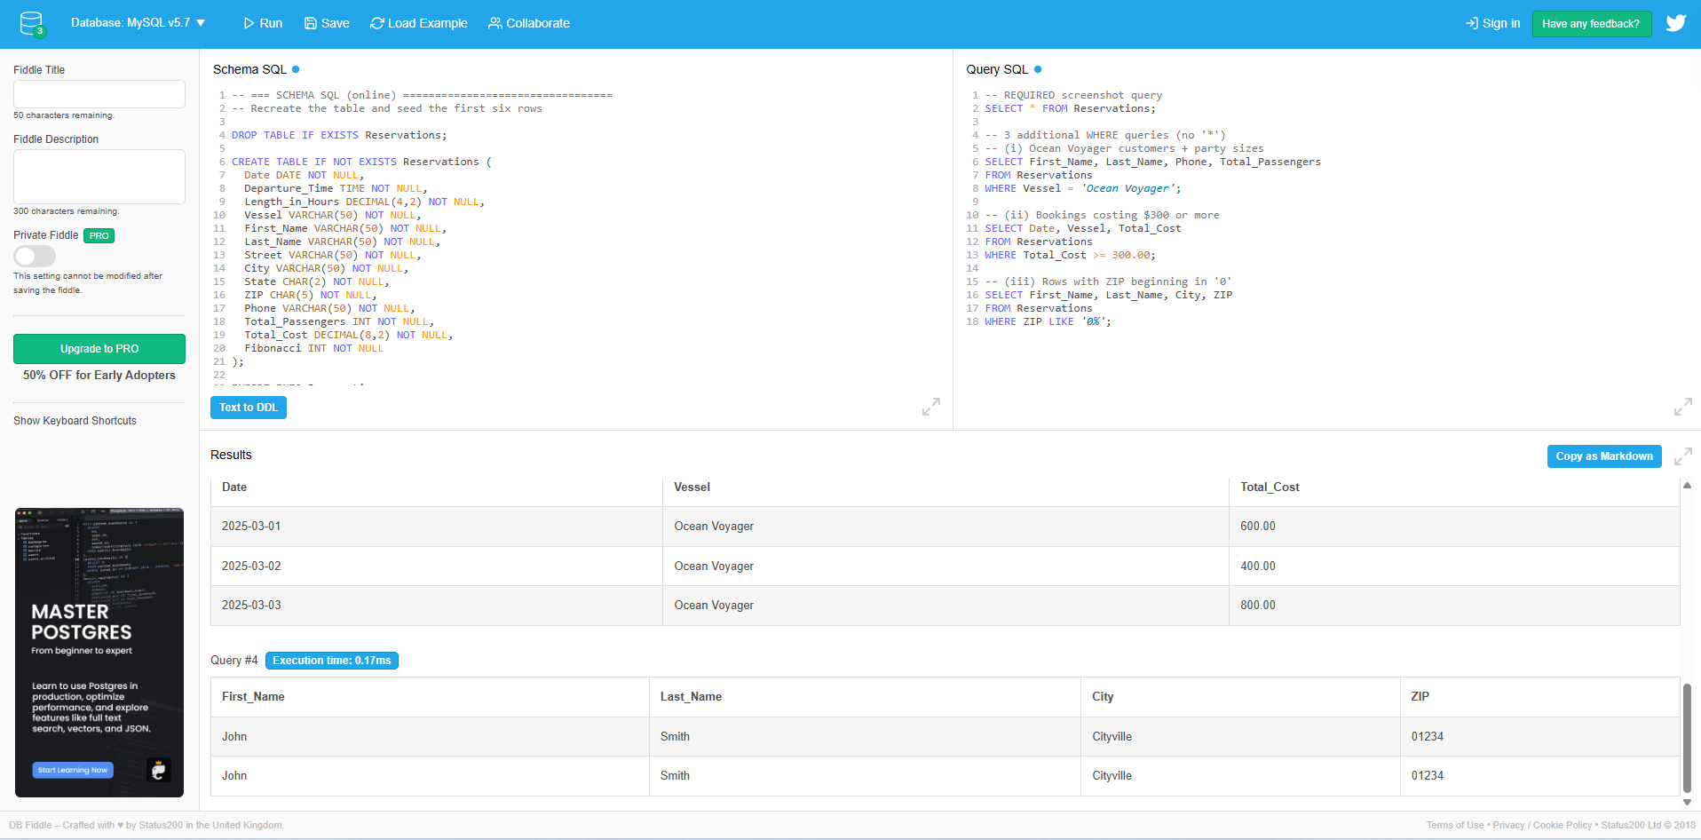

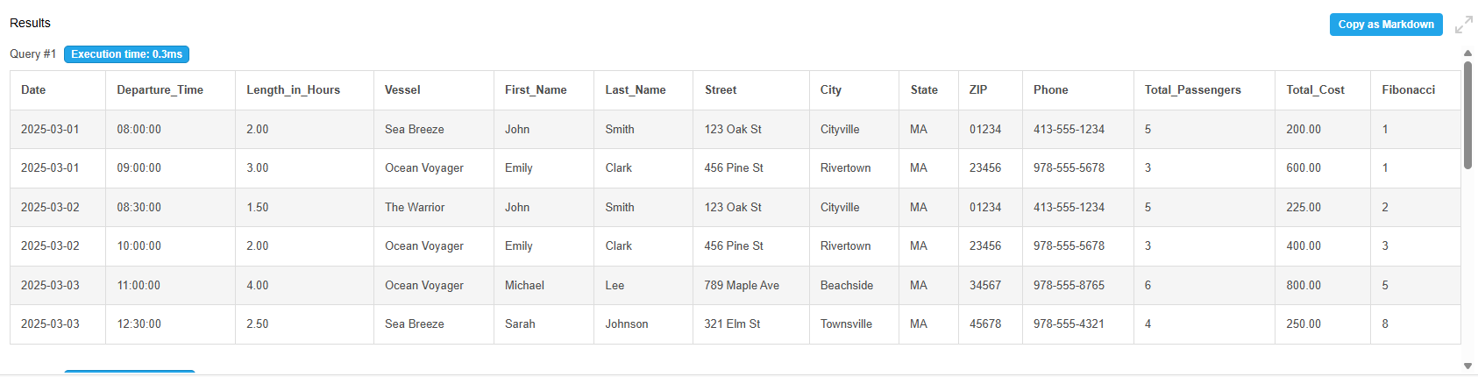

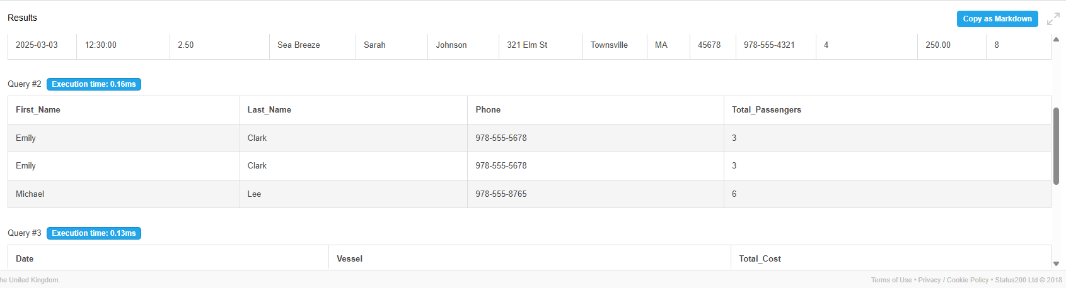

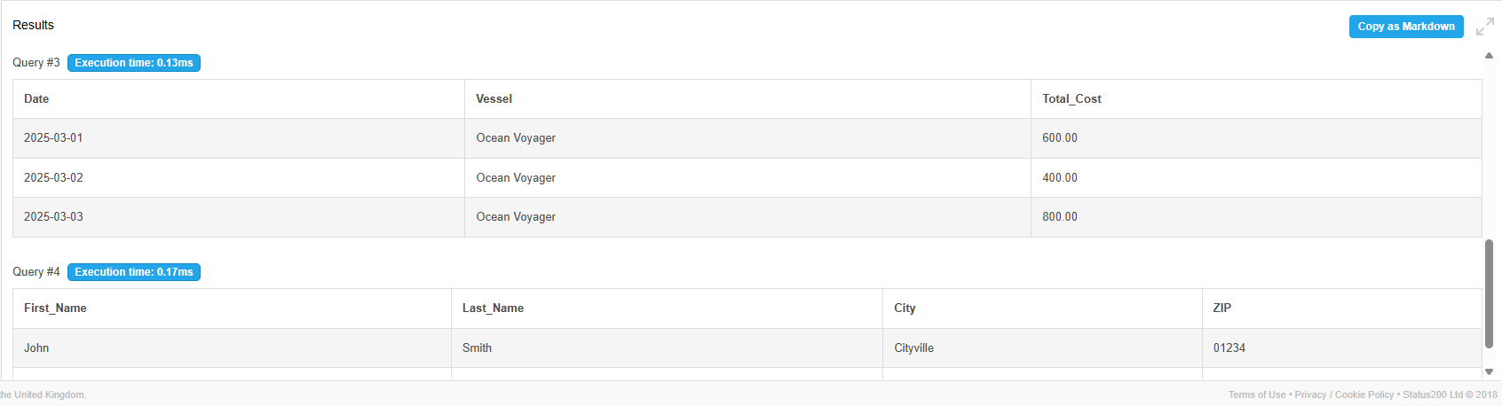

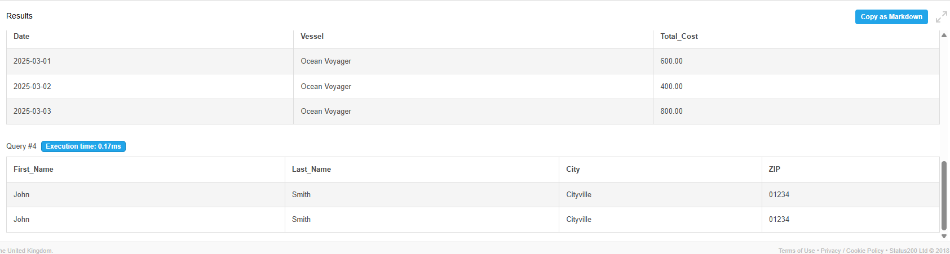
Schema SQL

-- === SCHEMA SQL (online) =================================
-- Recreate the table and seed the first six rows

DROP TABLE IF EXISTS Reservations;

CREATE TABLE IF NOT EXISTS Reservations (
Date DATE NOT NULL,
Departure_Time TIME NOT NULL,
Length_in_Hours DECIMAL(4,2) NOT NULL,
Vessel VARCHAR(50) NOT NULL,
First_Name VARCHAR(50) NOT NULL,
Last_Name VARCHAR(50) NOT NULL,
Street VARCHAR(50) NOT NULL,
City VARCHAR(50) NOT NULL,
State CHAR(2) NOT NULL,
ZIP CHAR(5) NOT NULL,
Phone VARCHAR(50) NOT NULL,
Total_Passengers INT NOT NULL,
Total_Cost DECIMAL(8,2) NOT NULL,
Fibonacci INT NOT NULL
);

INSERT INTO Reservations
(Date, Departure_Time, Length_in_Hours, Vessel, First_Name, Last_Name,
Street, City, State, ZIP, Phone, Total_Passengers, Total_Cost, Fibonacci)
VALUES
('2025-03-01','08:00',2.00,'Sea Breeze','John','Smith','123 Oak St','Cityville','MA','01234','413-555-1234',5,200.00,1),
('2025-03-01','09:00',3.00,'Ocean Voyager','Emily','Clark','456 Pine St','Rivertown','MA','23456','978-555-5678',3,600.00,1),
('2025-03-02','08:30',1.50,'The Warrior','John','Smith','123 Oak St','Cityville','MA','01234','413-555-1234',5,225.00,2),
('2025-03-02','10:00',2.00,'Ocean Voyager','Emily','Clark','456 Pine St','Rivertown','MA','23456','978-555-5678',3,400.00,3),
('2025-03-03','11:00',4.00,'Ocean Voyager','Michael','Lee','789 Maple Ave','Beachside','MA','34567','978-555-8765',6,800.00,5),
('2025-03-03','12:30',2.50,'Sea Breeze','Sarah','Johnson','321 Elm St','Townsville','MA','45678','978-555-4321',4,250.00,8);

Query SQL

-- REQUIRED screenshot query
SELECT * FROM Reservations;

-- 3 additional WHERE queries (no '*')
-- (i) Ocean Voyager customers + party sizes
SELECT First_Name, Last_Name, Phone, Total_Passengers
FROM Reservations
WHERE Vessel = 'Ocean Voyager';

-- (ii) Bookings costing $300 or more
SELECT Date, Vessel, Total_Cost
FROM Reservations
WHERE Total_Cost >= 300.00;

-- (iii) Rows with ZIP beginning in '0'
SELECT First_Name, Last_Name, City, ZIP
FROM Reservations
WHERE ZIP LIKE '0%';

